DWDL & Workflow Model Deployment Design
Version: | 0.3
Editors: | GH, RR, MA
Created: | 07.05.2009

Version | Date | Author(s) | Changes
0.1 | 05/10/2009 | GH | First release
0.2 | 05/11/2009 | RR | Corrected some small spelling errors, added scalability and security related parts
0.3 | 06/12/2009 | MA | Amendments after feedback from customer

Contents
1. Introduction 3
2. Package Structure 3
2.1. de.decidr.model.workflowmodel.deploy 3
2.2. de.decidr.model.workflowmodel.dwdl 3
2.3. de.decidr.model.workflowmodel.instancemanagement 4
3. Deployment 4
3.1. Deployer 4
3.2. ODESelector 4
3.3. FileDeployer 5
3.4. Validator 5
3.5. Parser 5
3.5.1. dwdl2bpel 5
3.5.2. dwdl2wsdl 5
3.5.3. dwdl2dd 5
3.5.4. dwdl2soap 5
Classes 6
3.5.5. Deployer 6
3.5.6. ODESelector 7
3.5.7. FileDeployer 7
3.5.8. Validator 8
3.5.9. Parser 8
3.5.10. dwdl2bpel 9
3.5.11. dwdl2wsdl 9
3.5.12. dwdl2dd 9
3.5.13. dwdl2soap 9
3.6. Sequence Diagram 9
4. DWDL 10
4.1. DWDL Structure 10
4.1.1. Basic Structure 10
4.1.2. Variables types 14
4.1.3. If Condition 15
4.1.4. Foreach Loop Evaluation 15
4.1.5. Email Activity 15
4.1.6. HumanTask Activity 16
4.2. DWDL2BPEL 17
4.2.1. Basic transformations 17
4.2.2. Variables 23
4.2.3. PartnerLinks 23
4.2.4. Control of process flow 23
4.2.5. Assignments 24
4.2.6. Correlations 25
4.2.7. Namespaces and Imports 25
4.3. DWDL2WSDL 26
5. Instance Management 28
5.1. InstanceManager 28
5.2. ServerSelector 28
5.3. SOAPGenerator 28
5.4. SOAPExecution 28
5.5. Classes 28
5.5.1. InstanceManager 29
5.5.2. ServerSelector 29
5.5.3. SOAPGenerator 30
5.5.4. SOAPExecution 30
5.6. Sequence Diagram 30
6. Design Decisions Related to Scalability and Security 30
6.1. Web Services 30
6.2. Apache ODE Engine: Workflow Instance Allocation 31
6.2.1. Monitoring of ODE Instances 31
6.3. Global View 32
6.4. Encryption 32
7. Appendix A: Human Task Web Service 33
7.1. Human Task Interaction 33
7.2. WSDL 34
7.3. XSD 39
8. Appendix B: Glossary 43

Introduction
This document describes the design of the "Decidr Workflow Definition Language" (DWDL), the design of the workflow deployment and the design of the instance manager. It also includes some basic thoughts on how to ensure scalability and security throughout the DecidR application.

Package Structure
The workflow deployment and instance management is contained in the package de.decidr.model.workflowmodel and consists of three packages, de.decidr.model.workflowmodel.deployment, de.decidr.model.workflowmodel.dwdl and de.decidr.model.workflowmodel.instancemanagement.

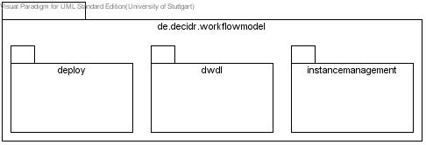
Figure 1: package overview

de.decidr.model.workflowmodel.deployment
The package de.decidr.model.workflowmodel.deployment contains the required classes to deploy a workflow model and offers an interface to access this functionality.

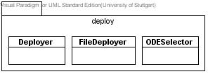
Figure 2: de.decidr.model.workflowmodel.deployment

de.decidr.model.workflowmodel.dwdl
The package de.decidr.model.workflowmodel.dwdl contains DWDL specific classes, which only offer functionality relevant to DWDL, like converting and validating a DWDL.

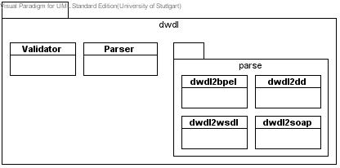
Figure 3: de.decidr.model.workflowmodel.dwdl

de.decidr.model.workflowmodel.instancemanagement
The package de.decidr.model.workflowmodel.instancemanagement contains all classes to manage (that is start and stop) an instance of a workflow model.

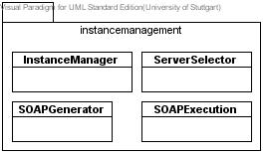
Figure 4: de.decidr.model.workflowmodel.instancemanagement

Deployment
The deployment of a workflow model consists of validating the DWDL of the workflow model, creating the required files to start a BPEL instance in the Apache ODE and deploying these files on the selected servers, so instances of this workflow model could be started.
The deployment is covered by the two packages de.decidr.model.workflowmodel.deployment and de.decidr.model.workflowmodel.dwdl, whose components are described underneath.

Deployer
The class "Deployer", contained in de.decidr.model.workflowmodel.deployment, controls the complete flow of deploying a workflow model. It also offers an interface for other components, to allow them to deploy a workflow model.

ODESelector
The class "ODESelector", contained in de.decidr.model.workflowmodel.deployment, uses a given list of servers and statistics of these servers (server load, deployed models) to determine on which servers a workflow model should be deployed, to ensure average load on all servers and prevent extreme load on single servers. This is achieved by deploying a workflow model on several servers (if more than one server is available). Therefore about 50% (if there is an uneven number of servers it will be rounded up) servers are selected, preferring the servers with the lowest load.

FileDeployer
The class "FileDeployer", contained in de.decidr.model.workflowmodel.deployment, covers the functionality to deploy given files (which are required to deploy a process in Apache ODE) on the selected servers. Therefore it uses the Deployment Web service of the Apache ODE on each server the workflow model should be deployed on. This Deployment Web service expects a zipped folder, containing the BPEL file, the deployment descriptor file and the WSDL file. These files are written locally into a temporary folder, zipped and sent to the Deployment Web services on all servers, which the workflow model has to be deployed on.

Validator
The class "Validator", contained in de.decir.model.workflowmodel.dwdl, provides the functionality to determine whether a given DWDL is valid or not.

Translator
The class "Translator", contained in de.decidr.model.workflowmodel.dwdl, provides the functionality to translate a given DWDL into different formats. Therefore it uses several other classes, contained in de.decidr.model.workflowmodel.dwdl.translator and described further down in this document. For easier translating and lower load, the class "Translator" converts the DWDL into an Object, using JAXB and passes this object to the specific parsing class.

dwdl2bpel
The class "dwdl2bpel", contained in de.decidr.model.workflowmodel.dwdl.translator, converts a given DWDL object and returns the resulting BPEL.
For information on how the DWDL is converted into BPEL, see DWDL2BPEL, page 17.

dwdl2wsdl
The class "dwdl2wsdl", contained in de.decidr.model.workflowmodel.dwdl.translator, converts a given DWDL object and returns the resulting WSDL.
For information on how the DWDL is converted into WSDL, see DWDL2WSDL, page 26.

dwdl2dd
The class "dwdl2dd", contained in de.decidr.model.workflowmodel.dwdl.translator, converts a given DWDL object and returns the resulting deployment descriptor.

dwdl2soap
The class "dwdl2soap", contained in de.decidr.model.workflowmodel.dwdl.translator, traverses a given WSDL and returns the resulting SOAP template, i.e. a SOAP message that holds wildcard characters for tag values.

Classes
In the following, all classes of the packages de.decidr.model.workflowmodel.deployment and de.decidr.model.workflowmodel.dwdl are described in detail.

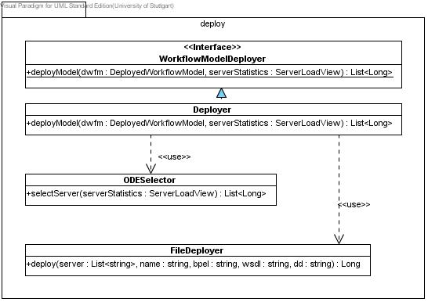
Figure 5: package deployment in detail

Deployer
This class provides an interface for other components to access the functionality to deploy a workflow instance.
The interface contains the function
deployModel (dwfm: DeployedWorkflowModel, serverStatistics:ServerLoadView) : List<Long>
This function expects the deployed workflow model of the workflow model which is to be deployed and a server load view, which lists all available servers and details of these servers, like server load, running instances, deployed models.
The function returns a list of Long values, the IDs of the servers, on which the workflow model has been deployed on, changes to the deployed workflow model don’t have to be returned to the calling component, since the Decidr Workflow Model (dwfm) is passed by reference.

If the function is called, the following steps are performed in the given order:
- Validate DWDL: The DWDL of the passed deployed workflow model is validated, using de.decidr.model.workflowmodel.dwdl.Validator. If validation fails, the Deployer won’t continue and raise an exception to inform the component which tried to deploy this workflow model.
- If the validation succeeds, the servers on which the workflow model shall be deployed are selected using de.decidr.model.workflowmodel.deployment.ODESelector. If no servers were found an exception is thrown to inform the component which tried to deploy this workflow model.
- If at least one server is available, the DWDL of the passed deployed workflow model is translated into the BPEL, WSDL, SOAP template and Deployment Descriptor, using de.decidr.model.workflowmodel.dwdl.Translator, which always returns strings.
- If this has not already been done, a unique name for the process is created (i.e. tenant_workflowmodelid) and stored (or read, if available) in the passed deployed workflow model.
- The SOAP template is stored in the passed deployed workflow model, the BPEL, WSDL and Deployment Descriptor are deployed on the selected servers using de.decidr.model.workflowmodel.deployment.FileDeployer.
The returned ODE version of the process is stored in the passed deployed workflow model.
- The function returns the list of server IDs on which the workflow has been deployed.

ODESelector
This class provides the possibility to select servers on which a workflow model could be deployed via the public function
selectServer(serverStatistics:ServerLoadView):List<Long>
This function expects a ServerLoadView, containing a list of all available servers as well as their IDs, paths, server load and deployed workflow instances. Using this information, the function chooses the 50% of these servers with the least load and returns a list of their IDs.

FileDeployer
This class provides the functionality to deploy the files of a workflow model process on selected servers using the public function
deploy(server:List<String>, name:string, bpel:string, wsdl: string, dd: string): Long
This function expects a list of the server addresses on which the files should be deployed, the name of the process which represents the name of the folder in the ODE and has to be unique for each workflow model, as well as the BPEL, WSDL and Deployment Descriptor as strings. If a process is deployed in Apache ODE, it automatically receives a version number, which is returned by the function deploy.
If the function is called, a folder with the passed name is created locally on the server. The passed BPEL, WSDL and Deployment Descriptor are written to files in this folder. This folder is compressed as a zip file. By invoking the Deployment Web service of the Apache ODEs on the given servers the zip file is deployed on all these servers. The returned ODE versions of the processes are collected, after all servers are handled the highest one is returned. After deploying the files on all servers, all files that have been created locally are deleted.

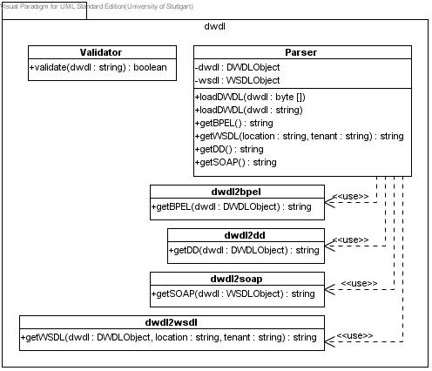
Figure 6: package dwdl in detail

Validator
This class provides the functionality to validate a passed DWDL via the public function
validate(dwdl:string):boolean
This functions expects a string, which is then validated. If the content of the string represents a valid DWDL, true is returned, if not, false is returned.
When the function is called, the passed string is validated against the DWDL Schema.

Translator
This class provides the functionality to parse and convert a given DWDL into different files, namely BPEL, WSDL, Deployment Descriptor and SOAP template.
Therefore it offers different functions:
load(dwdl:string)
load(dwdl:byte[])
These functions expect a DWDL, whether as string or byte-array, and transform it into a DWDL Object using JAXB.

getBPEL():string
This function calls the getBPEL function of de.decidr.model.workflowmodel.dwdl.parse.dwdl2bpel with the previously loaded DWDL Object and forwards the return value of the called function. If no DWDL Object is loaded an exception is thrown.

getWSDL(location:string, tenant:string):string
This function calls the getWSDL function of de.decidr.model.workflowmodel.dwdl.parse.dwdl2wsdl with the previously loaded DWDL Object as well as other required information to create the WSDL and forwards the return value of the called function. If no DWDL Object is loaded an exception is thrown.

getDD():string
This function calls the getDD function of de.decidr.model.workflowmodel.dwdl.parse.dwdl2dd with the previously loaded DWDL Object and forwards the return value of the called function. If no DWDL Object is loaded an exception is thrown.

getSOAP():string
This function calls the getSOAP function of de.decidr.model.workflowmodel.dwdl.parse.dwdl2soap with an WSDL Object, created from the previously retrieved WSDL and forwards the return value of the called function. If no DWDL Object is loaded or no WSDL has been parsed an exception is thrown.

dwdl2bpel
This class provides the functionality to parse a given DWDL and return BPEL, as needed to deploy it as a process in Apache ODE. Therefore the class offers the public function
getBPEL(dwdl: DWDLObject):string

dwdl2wsdl
This class provides the functionality to parse a given DWDL and return WSDL, as needed to deploy it as a process in Apache ODE. Therefore the class offers the public function
getWSDL(dwdl: DWDLObject):string

dwdl2dd
This class provides the functionality to parse a given DWDL and return a Deployment Descriptor, as needed to deploy it as a process in Apache ODE. Therefore the class offers the public function
getDD(dwdl: DWDLObject):string

dwdl2soap
This class provides the functionality to parse a given WSDL and return a SOAP template, which can be used later to start an instance of a deployed process on an Apache ODE. Therefore the class offers the public function
getSOAP(wsdl: WSDLObject):string

Sequence Diagram
In the following, a complete sequence of deploying a workflow instance is displayed.

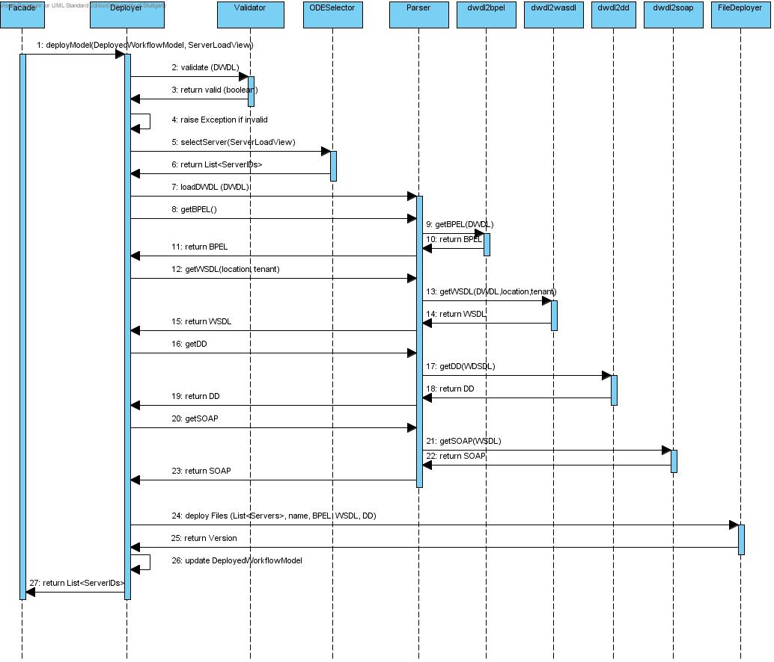
Figure 7: complete sequence of deploying a workflow model

DWDL
In the following the DWDL structure and how a DWDL can be converted into other formats is described.

DWDL Structure

Basic Structure
<workflow name=“NCName“ id=“ID“ targetNamespace=http://decidr.de/tenantName/NCName >
<description> ?
any content
</description>
<variables> ?
<variable name=“DWDLVariableName“
type=“DWDLVariableType“
configurationVariable=“yes|no“>
<initialValue> ?
any Literal
</initialValue>
</variable>
<variable name=“DWDLVariableName“
type=“DWDLVariableType“
configurationVariable=“yes|no“>
<intialValues> ?
<initialValue> +
any Literal
<initalValue>
<intialValues>
</variable>
<variable name=“DWDLVariableName“
type=“anyType“
configurationVariable=“yes|no“>
<initialValue>
any Content
</initialValue>
</variable>
</variables>
<roles> ?
<role name=“NCName“ /> *
<actor name=“NCName“ userid=“ID“ /> *
</roles>
<faultHandler> ?
<setProperty
name=“faultMessage“
variable=“DWDLVariableName“>
<propertyValue> ?
any value
</propertyValue>
</setProperty>
<informant> +
<setProperty
name=“name“
variable=“DWDLVariableName“>
<propertyValue> ?
any value
</propertyValue>
</setProperty>
<setProperty
name=“email“
variable=“DWDLVariableName“>
<propertyValue>
any value
</propertyValue>
</setProperty>
</informant>
</faultHandler>
<nodes> ?
<startNode name=“NCName“ id=“ID“>
<description> ?
any content
</description>
<graphics
x=“NCName“
y=“NCName“
width=“NCName“
height=“NCName“/>
<sources>
<source arcId=“IDREF“/> +
</sources>
</startNode>
<endNode name=“NCName“ id=“ID“>
<description> ?
any content
</description>
<graphics
x=“NCName“
y=“NCName“
width=“NCName“
height=“NCName“/>
<targets>
<target arcId=“IDREF“ /> +
</targets>
<notification> ?
<informant> +
<setProperty
name=“name“
variable=“DWDLVariableName“>
<propertyValue> ?
any value
</propertyValue>
</setProperty>
<setProperty
name=“email“
variable=“DWDLVariableName“>
<propertyValue>
any value
</propertyValue>
</setProperty>
</informant>
</notification>
</endNode>
<flowNode name=“NCName“ id=“ID“>
<description> ?
any content
</description>
<graphics
x=“NCName“
y=“NCName“
width=“NCName“
height=“NCName“/>
<targets>
<target arcId=“IDREF“ /> +
</targets>
<sources>
<source arcId=“IDREF“/> +
</sources>
<nodes>...</nodes>
<arcs>...</arcs>
</flowNode>
<ifNode name=“NCName“ id=“ID“>
<description> ?
any content
</description>
<graphics
x=“NCName“
y=“NCName“
width=“NCName“
height=“NCName“/>
<targets>
<target arcId=“IDREF“ /> +
</targets>
<sources>
<source arcId=“IDREF“/> +
</sources>
<condition order=“integer“>
<left-operand>left-spec</left-operand> ?
<operator>op-spec</operator> ?
<right-operand>right-spec</right-operand> ?
<nodes>...</nodes>
<arcs>...</arcs>
</condtion> +
</ifNode>
<forEachNode name=“NCName“ id=“ID“
counterName=“DWDLVariableName“
parallel=“yes|no“>
<description> ?
any content
</description>
<graphics
x=“NCName“
y=“NCName“
width=“NCName“
height=“NCName“/>
<targets>
<target arcId=“IDREF“ /> +
</targets>
<sources>
<source arcId=“IDREF“/> +
</sources>
<startCounterValue>
start-spec
</startCounterValue>
<finalCounterValue>
final-spec
</finalCounterValue>
<completionCondition>
comp-spec
</completionCondition>
<nodes>...</nodes>
<arcs>...</arcs>
</forEachNode>
<invokeNode name=“NCName“ id=“ID“
activity=“NCName“>
<description> ?
any content
</description>
<graphics
x=“NCName“
y=“NCName“
width=“NCName“
height=“NCName“/>
<targets>
<target arcId=“IDREF“ /> +
</targets>
<sources>
<source arcId=“IDREF“/> +
</sources>
<setProperty
name=“NCName“
variable=“DWDLVariableName“> *
<propertyValue> ?
any Value
</propertyValue>
</setProperty>
<getProperty
name=“NCName“
variable=“DWDLVariableName“ /> *
</invokeNode>
</nodes>
<arcs> ?
<arc name=“NCName“ id=“ID“
sourceNode=“IDREF“
targetNode=“IDREF“ /> +
</arcs>
</workflow>

Variables types
Simple types
Datatype | DWDL type | XML Schema type | Lexical Representation
Integer | „integer“ | xsd:integer | Integer has a lexical representation consisting of a finite-length sequence of decimal digits (#x30-#x39) with an optional leading sign. If the sign is omitted, "+" is assumed. For example: -1, 0, 12678967543233, +100000.
Float | „float“ | xsd:float | Float values have a lexical representation consisting of a mantissa followed, optionally, by the character "E" or "e", followed by an exponent. The exponent must be an integer. The mantissa must be a decimal number. The representations for exponent and mantissa must follow the lexical rules for integer and decimal. If the "E" or "e" and the following exponent are omitted, an exponent value of 0 is assumed.  The special values positive and negative zero, positive and negative infinity and not-a-number have the lexical representations 0, -0, INF, -INF and NaN, respectively.
String | „string“ | xsd:string | The value space of string is the set of finite-length sequences of characters.
Boolean | „boolean“ | xsd:boolean | An instance of a datatype that is defined as boolean can have the following legal literals {true, false}.
Date | „date“ | xsd:date | The lexical representation is the format CCYY-MM-DD where "CC" represents the century, "YY" the year, "MM" the month and "DD" the day an optional leading "-" sign to indicate a negative date. If the sign is omitted, "+" is assumed.
Time | “time” | xsd:time | The lexical representation is the format hh:mm:ss and "hh", "mm", "ss" represent hour, minute and second respectively.

Complex types
Datatype | DWDL type | Representation
File | „anyURI“ | The lexical space of anyURI is finite-length character sequences which are legal URIs according to [Uniform Resource Identifiers (URI): Generic Syntax.], as amended by [Format for Literal IPv6 Addresses in URL's].
Any Type | „anyType“ | See Basic Structure Section
List of Integer | „list-integer“ | see Basic Structure Section
List of Float | „list-float“ | see Basic Structure Section
List of String | „list-string“ | see Basic Structure Section
List of Boolean | „list-boolean“ | see Basic Structure Section
List of Date | „list-date“ | see Basic Structure Section
List of File | „list-file“ | see Basic Structure Section

If Condition
Left Operand | {$DWDLVariableName, $Role}
Operator | see SRS 4.4.2. If container
Right Operand | {$DWDLVariableName, $Role, value}

Foreach Loop Evaluation
startCounterValue | {Integer value} [default value = 1]
finalCounterValue | {$DWDLVariableName,  $Role, integer value}
completionCondition | {AND, XOR, OR}

Email Activity
<invokeNode name=“NCName“ id=“ID“
activity=“Decidr-Email“>
<description> ?
any content
</description>
<graphics
x=“NCName“
y=“NCName“
width=“NCName“
height=“NCName“/>
<targets>
<target arcId=“IDREF“ /> +
</targets>
<sources>
<source arcId=“IDREF“/> +
</sources>
<setProperty
name=“To“
variable=“DWDLVariableName“/>
<setProperty
name=“CC“
variable=“DWDLVariableName“/>
<setProperty
name=“BCC“
variable=“DWDLVariableName“/>
<setProperty
name=“Subject“
variable=“DWDLVariableName“/>
<setProperty
name=“Message“
variable=“DWDLVariableName“/>
<setProperty
name=“Attachement“
variable=“DWDLVariableName“/>
</invokeNode>

HumanTask Activity
<invokeNode name=“NCName“ id=“ID“
activity=“Decidr-HumanTask“>
<description> ?
any content
</description>
<graphics
x=“NCName“
y=“NCName“
width=“NCName“
height=“NCName“/>
<targets>
<target arcId=“IDREF“ /> +
</targets>
<sources>
<source arcId=“IDREF“/> +
</sources>
<setProperty
name=“WFM-ID“
variable=“DWDLVariableName“/>
<setProperty
name=“user“
variable=“DWDLVariableName“/>
<setProperty
name=“name“
variable=“DWDLVariableName“/>
<setProperty
name=“description“
variable=“DWDLVariableName“/>
<setProperty
name=“userNotification“
variable=“DWDLVariableName“/>
<outputVariable
name=“DWDLVariableName“
sourceProperty=“taskResult“ />
<taskData> ?
<item name="NCName"
variable=“DWDLVariableName“ ?
type="DWDLVariableType"
readOnly=“boolean“> +
<label>any string</label>
<hint>any string</hint> ?
<value>any value</value> ?
</item>
</taskData>
</invokeNode>

DWDL2BPEL

Basic transformations
<workflow name=“NCName“ id=“ID“>
<process name=“NCName“
targetNamespace="http://decidr.de/tenantName/processes/NCName"
xmlns="http://docs.oasis-pen.org/wsbpel/2.0/process/executable"
xmlns:xsd="http://www.w3.org/2001/XMLSchema"
xmlns:ode="http://www.apache.org/ode/type/extension"
queryLanguage="urn:oasis:names:tc:wsbpel:2.0:sublang:xpath1.0"
expressionLanguage="urn:oasis:names:tc:wsbpel:2.0:sublang:xpath1.0"
suppressJoinFailure="no"
exitOnStandardFault="no">

<description>
any content
</description>
<documentation>
any content
</documentation>

<variables>
<variable name=“DWDLVariableName“
type=“DWDLVariableType“
configurationVarialbe=“yes|no“>
<initialValue> ?
any Literal
</initialValue>
</variable>
<variable name=“DWDLVarialbeName“
type=“DWDLVariableType“
configurationVarialbe=“yes|no“>
<intialValues>
<initialValue>
any Literal
<initalValue>
<intialValues>
</variable>
<variable name=“DWDLVariableName“
type=“anyType“
configurationVarialbe=“yes|no“>
<initialValue>
any Content
</initialValue>
</variable>
</variables>
<variables>
<variable name=“BPELVariableName“
type=“QName“ />
</variables>

<roles>
<role name=“NCName“ />
<actor name=“NCName“ userid=“ID“ />
</roles>
<variable name=“NCName“ element=“role“>
<variable name=“NCName“ element=“actor“>

<faultHandler>
<setProperty
name=“faultMessage“
variable=“DWDLVariableName“>
<propertyValue>
any value
</propertyValue>
</setProperty>
<informant>
<setProperty
name=“name“
variable=“DWDLVariableName“>
<propertyValue>
any value
</propertyValue>
</setProperty>
<setProperty
name=“email“
variable=“DWDLVariableName“>
<propertyValue>
any value
</propertyValue>
</setProperty>
</informant>
</faultHandler>
<faultHandlers>
<catchAll>
<sequence>
<assign>
<copy>
<from variable=“DWDLVariableName“ />
<to variable="faultMessage" property="message" />
</copy>
<copy>
<from variable=“DWDLVariableName“ />
<to variable=“faultMessage“ property=“To“ />
</copy>
<copy>
<from>'Workflow Execution Failure'</from>
<to variable=“faultMessage“ property=“Subject“ />
</copy>
</assign>
<invoke partnerLink=“Email-WS“
operation=“sendEmail“
inputVariable=“faultMessage“
outputVarialbe=“faultMessageResponse“ />
</sequence>
</catchAll>
</faultHandlers>

<startNode name=“NCName“ id=“ID“>
<description>
any content
</description>
<graphics x=“NCName“ y=“NCName“ width=“NCName“ height=“NCName“/>
<sources>
<source arcId=“IDREF“/>
</sources>
</startNode>
<receive name=“NCName“
partnerLink="tenantName"
operation="startProcess"
variable="startConfigurations"
createInstance="yes">
<documentation>
any content
</documentation>
<sources>
<source linkName=“IDREF“ />
</sources>
</receive>

<endNode name=“NCName“ id=“ID“>
<description>
any content
</description>
<graphics x=“NCName“ y=“NCName“ width=“NCName“ height=“NCName“/>
<targets>
<target arcId=“IDREF“ />
</targets>
<notification>
<informant>
<setProperty
name=“name“
variable=“DWDLVariableName“>
<propertyValue>
any value
</propertyValue>
</setProperty>
<setProperty
name=“email“
variable=“DWDLVariableName“>
<propertyValue>
any value
</propertyValue>
</setProperty>
</informant>
</notification>
</endNode>
<sequence>
<assign>
<copy>
<from>'Workflow Execution Success'</from>
<to variable="successMessage" property="message" />
</copy>
<copy>
<from variable=“DWDLVariableName“ />
<to variable=“successMessage“ property=“To“ />
</copy>
<copy>
<from>'Workflow Execution Success'</from>
<to variable=“successMessage“ property=“Subject“ />
</copy>
</assign>
<invoke partnerLink=“Email-WS“
operation=“sendEmail“
inputVariable=“successMessage“
outputVarialbe=“successMessageResponse“ />
</sequence>

<flowNode name=“NCName“ id=“ID“>
<description>
any content
</description>
<graphics x=“NCName“ y=“NCName“ width=“NCName“ height=“NCName“/>
<targets>
<target arcId=“IDREF“ />
</targets>
<sources>
<source arcId=“IDREF“/>
</sources>
<nodes>...</nodes>
<arcs>...</arcs>
</flowNode>
<flow name=“NCName“>
<documentation>
any content
</documentation>
<targets>
<target linkName=“IDREF“/>
</targets>
<sources>
<source linkName=“IDREF“/>
</sources>
<links>
...
</links>
activity
</flow>

<ifNode name=“NCName“ id=“ID“>
<description>
any content
</description>
<graphics x=“NCName“ y=“NCName“ width=“NCName“ height=“NCName“/>
<targets>
<target arcId=“IDREF“ />
</targets>
<sources>
<source arcId=“IDREF“/>
</sources>
<condition order=“integer“>
<left-operand>left-spec</left-operand>
<operator>op-spec</operator>
<right-operand>right-spec</right-operand>
<nodes>...</nodes>
<arcs>...</arcs>
</condtion>
</ifNode>
<if name=“NCName“>
<condition> left-spec op-spec right-spec</condition>
activity
<elseif>
<condition>...</condition>
activity
</elseif>
<else>
activity
</else>
</if>

<forEachNode name=“NCName“ id=“ID“
counterName=“DWDLVariableName“
parallel=“yes|no“>
<description>
any content
</description>
<graphics x=“NCName“ y=“NCName“ width=“NCName“ height=“NCName“/>
<targets>
<target arcId=“IDREF“ />
</targets>
<sources>
<source arcId=“IDREF“/>
</sources>
<startCounterValue>
start-spec
</startCounterValue>
<finalCounterValue>
final-spec
</finalCounterValue>
<completionCondition>
comp-spec
</completionCondition>
<nodes>...</nodes>
<arcs>...</arcs>
</forEachNode>
<forEach name=“NCName“
counterName="BPELVariableName"
parallel="yes|no">
<startCounterValue>unsigned-integer-expression</startCounterValue>
<finalCounterValue>unsigned-integer-expression</finalCounterValue>
<completionCondition>
<branches
successfulBranchesOnly="yes">
unsigned-integer-expression
</branches>
</completionCondition>
<scope ...>...</scope>
</forEach>

<invokeNode name=“NCName“ id=“ID“
activity=“NCName“>
<description> ?
any content
</description>
<graphics x=“NCName“ y=“NCName“ width=“NCName“ height=“NCName“/>
<targets>
<target arcId=“IDREF“ />
</targets>
<sources>
<source arcId=“IDREF“/>
</sources>
<setProperty
name=“NCName“
variable=“DWDLVariableName“>
<propertyValue>
any Value
</propertyValue>
</setProperty>
<getProperty
name=“NCName“
varialbe=“DWDLVariableName“ />
</invokeNode>
<sequence>
<assign>
...
</assign>
<invoke name=“NCName“
partnerLink="NCName"
operation="NCName"
inputVariable="BPELVariableName"
outputVariable="BPELVariableName">
<correlations>
<correlation set="NCName" initiate="yes|join|no"
pattern="request|response|request-response" />
</correlations>
</invoke>
</sequence>

<arcs>
<arc name=“NCName“ id=“ID“
sourceNode=“IDREF“
targetNode=“IDREF“ />
</arcs>
<links>
<link name=“ID“ />
</links>

Variables
<variable name=“startConfigurations“
messageType=“startMessage“ />
<variable name=“WFMID“ type=“ID“ />

<variable name=“faultMessage“
messageType=“sendEmailRequest“ />
<variable name=“faultMessageResponse“
messageType=“sendEmailResponse“ />

<variable name=“successMessage“
messagetype=“sendEmailRequest“ />
<variable name=“successMessageResponse“
messagetype=“sendEmailResponse“ />

<variable name=“taskMessage“
messagetype=“createTaskRequest“ />
<variable name=“taskMessageResponse“
messagetype=“createTaskResponse“ />
<variable name=“taskDataMessage“
messagetype=“taskResponse“ />

PartnerLinks
<partnerLinks>
<partnerLink name=“tenantName“
partnerLinkType=“TenantName-PLT“
myRole=“processProvider“>
<partnerLink name="Email-WS"
partnerLinkType="Email-WS-PLT"
partnerRole="Email-WS-Provider" />
<partnerLink name=“HumanTask-WS“
partnerLinkType=“HumanTask-WS-PLT“
myRole=“HumanTask-WS-Client“
partnerRole=“HumanTask-WS-Provider“ />
</partnerLinks>

Control of process flow
<workflow>  <nodes>  <startNode />  <flowNode />  <ifNode />  <forEachNode />  <invokeNode />  <endNode />  </nodes>  <arcs>  <arc id=“1“ />  <arc id=“2“ />  <arc id=“3“ />  </arcs>  </workflow> | <process>  <flow>  <links>  <link name=“1“ />  <link name=“2“ />  <link name=“3“ />  </links>  <assign />  <receive />  <flow />  <if />  <forEach />  <invoke />  <reply />  </flow>  </process>

<forEachNode/> | <sequence>  <assign />  <forEach />  <assign />  </sequence>

<invokeNode/> | <sequence>  <assign />  <invoke />  <receive />  <assign />  </sequence>

Assignments
<workflow name=“NCName“ id=“ID“>
<assign>
<copy>
<from><literal>ID</literal></from>
<to variable=“WFMID“ />
</copy>
</assign>

<variable name=“DWDLVariableName“
type=“DWDLVariableType“
configurationVarialbe=“yes“>
</variable>
<assign>
<copy>
<from variable=startConfigurations property=“DWDLVariableName“ />
<to variable=“DWDLVariableName“ />
</copy>
</assign>

<variable name=“DWDLVariableName“
type=“DWDLVariableType“
configurationVarialbe=“no“>
<initialValue>
any Literal
</initialValue>
</variable>
<assign>
<copy>
<from><literal>any Literal</literal></from>
<to variable=“DWDLVariableName“ />
</copy>
</assign>

<variable name=“DWDLVariableName“
type=“DWDLVariableType“
configurationVarialbe=“no“>
<initialValues>
<initialValue>
value1
</initalValue>
<initialValue>
value2
</initialValue>
</initialValues>
</variable>
<assign>
<copy>
<from><literal>value1 value2</literal></from>
<to variable=“DWDLVariableName“ />
</copy>
</assign>

Correlations
<correlationSets>
<correlationSet name="standard-correlation"
properties="processID taskID userID" />
</correlationSets>

Namespaces and Imports
<xmlns:ews="http://decidr.de/websercices/Email-WS"
xmlns:htws="http://decidr.de/websercices/HumanTask-WS" />

<import namespace="http://decidr.de/webservices/Email"
location="Email-WS.wsdl"
importType="http://schemas.xmlsoap.org/wsdl/" />
<import namespace="http://decidr.de/webservices/HumanTask"
location=“HumanTask-WS.wsdl“
importType=“http://schemas.xmlsoap.org/wsdl/“ />

DWDL2WSDL

<?xml version="1.0" encoding="UTF-8" standalone="no"?>
<definitions name="NCName"
targetNamespace="http://decidr.de/tenantName/processes/NCName"
xmlns="http://schemas.xmlsoap.org/wsdl/"
xmlns:http="http://schemas.xmlsoap.org/wsdl/http/"
xmlns:mime="http://schemas.xmlsoap.org/wsdl/mime/"
xmlns:plnk="http://docs.oasis-open.org/wsbpel/2.0/plnktype"
xmlns:soap="http://schemas.xmlsoap.org/wsdl/soap/"
xmlns:tns="http://decidr.de/tenantName/wsdl/NCName"
xmlns:vprop="http://docs.oasis-open.org/wsbpel/2.0/varprop" >

<types>
<schema>
<complexType name=“startMessage“>
<sequence>
<choice>
<element name=“DWDLVariableName“ type=“integer“ />
<element name=“DWDLVariableName“ type=“float“ />
<element name=“DWDLVariableName“ type=“string“ />
<element name=“DWDLVariableName“ type=“boolean“ />
<element name=“DWDLVariableName“ type=“date“ />
<element name=“DWDLVariableName“ type=“anyURI“ />
<element name=“DWDLVariableName“ type=“list-integer“ />
<element name=“DWDLVariableName“ type=“list-float“ />
<element name=“DWDLVariableName“ type=“list-string“ />
<element name=“DWDLVariableName“ type=“list-boolean“ />
<element name=“DWDLVariableName“ type=“list-date“ />
<element name=“DWDLVariableName“ type=“list-anyURI“ />
<element name=“DWDLVariableName“ type=“list-anyURI“ />
<element ref=“actor“ />
<element ref=“role“ />
</choice>
</sequence>
</complexType>
</schema>
</types>

<message name="processIn">
<part name="payload" type="startMessage"/>
</message>
<message name=“processOut“>
<part name=“payload“ type=“responseMessage“ />
</message>

<partnerLinkType name="TenantName-PLT">
<role name="processProvider" portType="NCName-PortType" />
</partnerLinkType>

<portType name="NCName-PT">
<operation name="startProcess">
<input message="processIn"/>
</operation>
</portType>
<portType name=“HumanTask-CallbackPT“>
<operation name=“setTaskData“
<input message=“taskDataMessage“ />
</operation>
</portType>

<service name="NCName-Service">
<port name="NCName-PortName" binding="SoapBinding">
<address location=""/>
</port>
<port name=“HumanTask-CallbackPT“ binding=“SoapCallbackBinding“>
<address location=““ />
</port>
</service>

<binding name="SoapBinding" type="NCName-PT">
<soap:binding
style="document"
transport="http://schemas.xmlsoap.org/soap/http"/>
<soap:operation name="startProcess" />
<operation>
<input>
<soap:body use="literal"/>
</input>
</operation>
</binding>
<binding name=“SoapCallbackBinding“ type=“NCName-Callback-PortType“>
<soap:binding
style="document"
transport="http://schemas.xmlsoap.org/soap/http"/>
<operation name="sendTaskData">
<soap:operation/>
<input>
<soap:body use="literal"/>
</input>
</operation>
</binding>

<property name=“DWDLVariableName“ type=“DWDLVariableType“>

<propertyAlias
propertyName="DWDLVariableName"
messageType="startMessage" />
</propertyAlias>

Instance Management
The instance management provides the functionality to start and stop instances of deployed workflow models on one Apache ODE.
This functionality is provided by the package de.decidr.model.workflowmodel.instancemanagement.

InstanceManager
The class "InstanceManager”, contained in de.decidr.model.workflowmodel.instancemanagement, provides the functionality to start and stop instances of deployed workflow models on Apache ODE. It also offers an interface to allow other components to access this functionality.

ServerSelector
The class "ServerSelector”, contained in de.decidr.model.workflowmodel.instancemanagement, uses a passed list of servers, on which a specific workflow model is deployed, to select on which server a new instance of this process should be started.

SOAPGenerator
The class "SOAPGenerator”, contained in de.decidr.model.workflowmodel.instancemanagement, generates a SOAP message, using the SOAP template of a workflow model and a start configuration, to fill the template with data.

SOAPExecution
The class "SOAPExecution”, contained in de.decidr.model.workflowmodel.instancemanagement, invokes a Web service with a given SOAP message.

Classes
In the following all classes of the package de.decidr.model.workflowmodel.instancemanagement are described in detail.

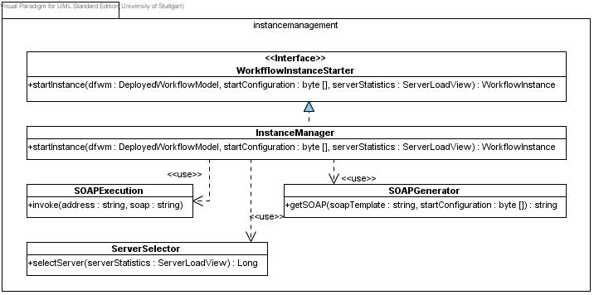
Figure 8: package instancemanagement in detail

InstanceManager
This class provides the interface to access the functionality to start and stop instances of deployed workflow models.
The interface contains the function
startInstance(dwfm:DeployedWorkflowModel, startConfiguration:byte[], serverStatistics:ServerLoadView):WorkflowInstance
The function expects a deployed workflow model, which contains the required SOAP Template and the start configuration, and a server load view, containing a list of servers on which the workflow model is deployed, their ID, load, running instances and a byte-array, containing the start configuration. If successful the instance returns the newly created WorkflowInstance, containing all relevant data.

If the function is called, the following steps are performed in the following order:
- Select one server, using de.decidr.model.workflowmodel.instancemanagement.ServerSelector on which the instance could be started. If no server is available an exception is raised.
- If a server was found, the SOAP message to start an instance is created, using de.decidr.model.workflowmodel.instancemanagement.SOAPGenerator with the SOAP template and start configuration of the given deployed workflow model.
- With the created SOAP message a new instance is started, invoking the process’ Web service using de.decidr.model.workflowmodel.instancemanagement.SOAPExecution
- A new WorkflowInstance object is created with the available data (process ID, …) and returned.

ServerSelector
This class provides the functionality to select one server, on which a new instance should be started to balance load between all servers via the public function
selectServer(serverStatistics:ServerLoadView):Long
The function expects a ServerLoadView and selects the server with the least load of the given servers and returns its ID.

SOAPGenerator
This class generates a SOAP message through the public function
getSOAP(template:string,startConfig:byte[]):string
The function expects a SOAP template and a start configuration. Using this input, the function generates a complete SOAP message which can be used to start a new instance of a deployed workflow model with the information contained in the starting configuration. The generated SOAP message is returned.

SOAPExecution
This class provides the functionality to invoke a Web service with the given SOAP message via the public function
invoke(address:string, soap:string)
The function expects the address of a Web service and a matching SOAP message. If the function is called, the specified Web service is invoked using the provided SOAP message.

Sequence Diagram
In the following you can see a complete sequence of starting a new process instance.

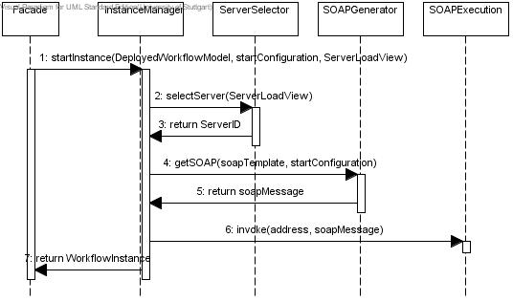
Figure 9: sequence of starting a new process instance

Design Decisions Related to Scalability and Security

Web Services
- Web services may be located on any server within the DecidR system.
- Multiple Web services may be located on one server.
- “Web service bundles” may be pre-configured (as time permits), based on the actual load caused by the Web service.
  - Example: Suppose the HT-WS causes a major load on servers. This means that the HT-Web service should probably be assigned at least one dedicated server. Suppose also, the email-WS causes only a negligible load on the system. This indicates that it may be used to fill free capacities on little- or unused servers.
- The ESB must know the location of every Web service in the DecidR system.
- Every message must be routed through & by the ESB.
  - The ESB must know which ODE instance to route appropriate messages to.
  - The ESB is a bottle-neck since there is only one in the whole DecidR system (the customer considers this acceptable).
  - Every message has to be encrypted and possibly signed.

Apache ODE Engine: Workflow Instance Allocation
- There is a pool of readily available ODE instances. The number of ODE instances in this pool can be configured by the system administrator.
- A new workflow instance is started on an unlocked machine with the lowest load average, rounded to the nearest 5%. Should there be more than one server matching this description, the implementation may choose any server that fits the description.
- Any ODE instance on a machine with a load average of over x% or with y or more running workflow instances is locked until the average drops below z% and less than y workflow instances are running (where x, y and z are configurable by the system administrator).
- Should the amount of unlocked ODE instances drop below a number specified by the system administrator, a new instance should be started, depending on the infrastructure. This could mean that a new EC² instance is started, a new ODE instance is created on an available server or simply that a message is sent to the system administrator with a request to make an new ODE instance available.
- There has to be a monitoring mechanism that supervises the available ODE instances and coordinates the assignment of new workflow instances to available ODE instances.

Monitoring of ODE Instances
- There are two monitoring components:
  - The “ODE Monitoring Client”
    - This is a dedicated program which should run on any machine an ODE instance may run on. It will use the “ODE Management API” to interface with the ODE instance it supervises.
  - The “ODE Monitoring Server”
    - This will be implemented as a Web service so that we won't have to implement a server.
- The “ODE Monitoring Client”
  - must register with the “ODE Monitoring Server”
  - collects the following information:
    - system load average
    - number of running workflow instances
  - may start/stop an ODE instance
  - sends the following data to the “ODE Monitoring Server”:
    - load average (every x seconds, where x is configurable by the system administrator)
    - number of running workflow instances (whenever a workflow instance is started stopped)
- The “ODE Monitoring Server”
  - locks/unlocks ODE instances based on their load average and the number of workflow instances running on them
  - stores the data sent by each “ODE Monitoring Client” in the Database
  - tells the “ODE Monitoring Client” to start/stop its ODE instance or requests that the system administrator make a new ODE instance available

Global View
- There is no reason to deliberately keep Apache ODE instances and Web services on separate servers.
  - We should pre-configure some Web service and ODE bundles for the system administrator to choose from. The configuration of these bundles should be determined by comparing the system load caused by each component in the stress testing phase. The system administrator should be given the choice to start and stop any component on any server at any time. The time required between issuing the start/stop command and the actual status change to available/unavailable depends on the component instance. The stopping of a component instance (e.g. an ODE Engine) may be delayed until all tasks are finished.
- There should be a server dedicated to the Apache Synapse ESB since the ESB will constitute a bottleneck.
- Any kind of redundancy is optional in the case of the ESB and will therefore have a low priority.

Encryption
- All communication between DecidR components must be encrypted where possible unless it can be guaranteed that the communication does not cross a network.
- Only the body of a SOAP message has to be encrypted.
- Whole messages or parts of messages may be signed if there is sufficient time (low priority feature).
- Each DecidR-Component and -Web service type has their individual keypair, generated during the installation process.
- Each DecidR-Component and -Web service will know the public key of every DecidR-Component and -Web service type. This allows for finer grained trust management in the future.

Appendix A: Human Task Web Service
In addition to “chapter 4: DWDL” the WSDL and XSD of the Human Task Web service.

Human Task Interaction
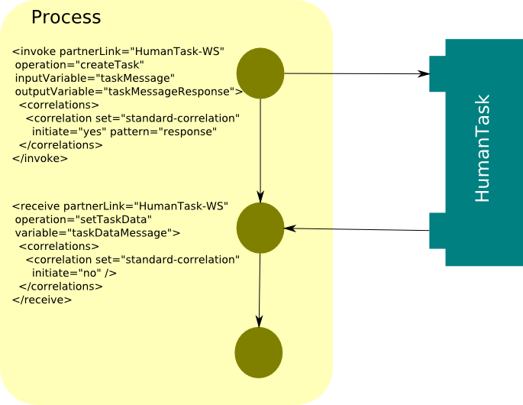

WSDL

<?xml version="1.0" encoding="UTF-8" standalone="no"?>
<wsdl:definitions xmlns:soap="http://schemas.xmlsoap.org/wsdl/soap12/"
xmlns:tns="http://decidr.de/webservices/HumanTask" xmlns:wsdl="http://schemas.xmlsoap.org/wsdl/"
xmlns:xsd="http://www.w3.org/2001/XMLSchema" xmlns:decidr="http://decidr.de/schema/DecidrTypes"
xmlns:dwsdl="http://decidr.de/wsdl/DecidrTypes" xmlns:plnk="http://docs.oasis-open.org/wsbpel/2.0/plnktype"
name="HumanTask" targetNamespace="http://decidr.de/HumanTask/">

<wsdl:types>
<xsd:schema targetNamespace="http://decidr.de/webservices/HumanTask">
<!-- own type definitions -->
<xsd:import schemaLocation="DecidrTypes.xsd"
namespace="http://decidr.de/schema/DecidrTypes" />

<!-- operations -->
<xsd:element name="createTask">
<xsd:complexType>
<xsd:sequence maxOccurs="1" minOccurs="1">
<xsd:element name="taskID" type="decidr:tID"
minOccurs="1" maxOccurs="1" nillable="false" />
<xsd:element name="wfmID" type="decidr:tID" minOccurs="1"
maxOccurs="1" nillable="false">
<xsd:annotation>
<xsd:documentation>Workflow Model ID</xsd:documentation>
</xsd:annotation>
</xsd:element>
<xsd:element name="processID" type="decidr:tID"
minOccurs="1" maxOccurs="1" nillable="false" />
<xsd:element name="userID" type="decidr:tID"
minOccurs="1" maxOccurs="1" nillable="false" />
<xsd:element name="taskName" type="xsd:string"
minOccurs="1" maxOccurs="1" nillable="false" />
<xsd:element name="userNotification" type="xsd:boolean"
minOccurs="0" maxOccurs="1" nillable="false" default="false" />
<xsd:element name="description" type="xsd:string"
minOccurs="1" maxOccurs="1" nillable="false" />
<xsd:element name="taskData" type="decidr:tItemList"
minOccurs="0" maxOccurs="1" nillable="false" />
</xsd:sequence>
</xsd:complexType>
</xsd:element>
<xsd:element name="createTaskResponse">
<xsd:complexType>
<xsd:sequence />
</xsd:complexType>
</xsd:element>
<xsd:element name="taskCompleted">
<xsd:complexType>
<xsd:sequence>
<xsd:element name="taskID" type="decidr:tID"
minOccurs="1" maxOccurs="1" nillable="false" />
</xsd:sequence>
</xsd:complexType>
</xsd:element>
<xsd:element name="" taskCompleted " Response ">
<xsd:complexType>
<xsd:sequence />
</xsd:complexType>
</xsd:element>
<xsd:element name="removeTasks">
<xsd:complexType>
<xsd:sequence>
<xsd:element name="processID" type="decidr:tID"
minOccurs="1" maxOccurs="1" nillable="false" />
</xsd:sequence>
</xsd:complexType>
</xsd:element>
<xsd:element name="removeTasksResponse">
<xsd:complexType>
<xsd:sequence />
</xsd:complexType>
</xsd:element>
<xsd:element name="removeTask">
<xsd:complexType>
<xsd:sequence>
<xsd:element name="taskIDList" type="decidr:tIDList"
minOccurs="1" maxOccurs="1" nillable="false" />
</xsd:sequence>
</xsd:complexType>
</xsd:element>
<xsd:element name="removeTaskResponse">
<xsd:complexType>
<xsd:sequence />
</xsd:complexType>
</xsd:element>
</xsd:schema>
</wsdl:types>

<wsdl:message name="createTaskRequest">
<wsdl:part element="tns:createTask" name="parameters" />
</wsdl:message>
<wsdl:message name="createTaskResponse">
<wsdl:part element="tns:createTaskResponse" name="parameters" />
</wsdl:message>
<wsdl:message name="taskCompletedRequest">
<wsdl:part element="tns:taskCompleted" name="parameters" />
</wsdl:message>
<wsdl:message name="taskCompletedResponse">
<wsdl:part element="tns:taskCompletedResponse" name="parameters" />
</wsdl:message>
<wsdl:message name="removeTasksRequest">
<wsdl:part element="tns:removeTasks" name="parameters" />
</wsdl:message>
<wsdl:message name="removeTasksResponse">
<wsdl:part element="tns:removeTasksResponse" name="parameters" />
</wsdl:message>
<wsdl:message name="removeTaskRequest">
<wsdl:part element="tns:removeTask" name="parameters" />
</wsdl:message>
<wsdl:message name="removeTaskResponse">
<wsdl:part element="tns:removeTaskResponse" name="parameters" />
</wsdl:message>

<wsdl:portType name="HumanTaskPT">
<wsdl:operation name="createTask">
<wsdl:input message="tns:createTaskRequest" />
<wsdl:output message="tns:createTaskResponse" />
</wsdl:operation>
<wsdl:operation name="taskCompleted">
<wsdl:input message="tns:taskCompletedRequest" />
<wsdl:output message="tns:taskCompletedResponse" />
</wsdl:operation>
<wsdl:operation name="removeTasks">
<wsdl:input message="tns:removeTasksRequest" />
<wsdl:output message="tns:removeTasksResponse" />
</wsdl:operation>
<wsdl:operation name="removeTask">
<wsdl:input message="tns:removeTaskRequest" />
<wsdl:output message="tns:removeTaskResponse" />
</wsdl:operation>
</wsdl:portType>
<plnk:partnerLinkType name="HumanTaskPLT">
<plnk:role name="HumanTaskProvider" portType="tns:HumanTaskPT" />
<plnk:role name="HumanTaskClient" portType="dwsdl:HumanTask-CallbackPT" />
</plnk:partnerLinkType>

<wsdl:binding name="HumanTaskSOAP" type="tns:HumanTaskPT">
<soap:binding style="document"
transport="http://schemas.xmlsoap.org/soap/http" />
<wsdl:operation name="createTask">
<soap:operation soapAction="http://decidr.de/webservices/HumanTask/createTask"
style="document" />
<wsdl:input>
<soap:body use="literal" />
</wsdl:input>
<wsdl:output>
<soap:body use="literal" />
</wsdl:output>
</wsdl:operation>
<wsdl:operation name="taskCompleted">
<soap:operation
soapAction="http://decidr.de/webservices/HumanTask/taskCompleted"
style="document" />
<wsdl:input>
<soap:body use="literal" />
</wsdl:input>
<wsdl:output>
<soap:body use="literal" />
</wsdl:output>
</wsdl:operation>
<wsdl:operation name="removeTasks">
<soap:operation soapAction="http://decidr.de/webservices/HumanTask/removeTasks"
style="document" />
<wsdl:input>
<soap:body use="literal" />
</wsdl:input>
<wsdl:output>
<soap:body use="literal" />
</wsdl:output>
</wsdl:operation>
<wsdl:operation name="removeTask">
<soap:operation soapAction="http://decidr.de/webservices/HumanTask/removeTask"
style="document" />
<wsdl:input>
<soap:body use="literal" />
</wsdl:input>
<wsdl:output>
<soap:body use="literal" />
</wsdl:output>
</wsdl:operation>
</wsdl:binding>

<!-- needs to be adapted for deployment -->
<wsdl:service name="HumanTask">
<wsdl:port binding="tns:HumanTaskSOAP" name="HumanTaskSOAP">
<soap:address location="http://www.example.org/" />
</wsdl:port>
</wsdl:service>
</wsdl:definitions>

XSD
<?xml version="1.0" encoding="UTF-8"?>

<xsd:schema xmlns:xsd="http://www.w3.org/2001/XMLSchema"
targetNamespace="http://decidr.de/schema/DecidrTypes" xmlns:tns="http://decidr.de/schema/DecidrTypes"
elementFormDefault="qualified">

<xsd:element name="actor" type="tns:tActor" />
<xsd:complexType name="tActor">
<xsd:attribute name="name" type="xsd:NCName" />
<xsd:attribute name="userid" type="xsd:ID" use="required" />
<xsd:attribute name="email" type="xsd:string" />
</xsd:complexType>

<xsd:element name="role" type="tns:tRole" />
<xsd:complexType name="tRole">
<xsd:sequence>
<xsd:element ref="tns:actor" />
</xsd:sequence>
<xsd:attribute name="name" type="xsd:NCName" use="required" />
</xsd:complexType>

<xsd:simpleType name="list-integer">
<xsd:list itemType="xsd:integer" />
</xsd:simpleType>

<xsd:simpleType name="list-float">
<xsd:list itemType="xsd:float" />
</xsd:simpleType>

<xsd:simpleType name="list-string">
<xsd:list itemType="xsd:string" />
</xsd:simpleType>

<xsd:simpleType name="list-boolean">
<xsd:list itemType="xsd:boolean" />
</xsd:simpleType>

<xsd:simpleType name="list-date">
<xsd:list itemType="xsd:date" />
</xsd:simpleType>

<xsd:simpleType name="list-file">
<xsd:list itemType="xsd:anyURI" />
</xsd:simpleType>

<xsd:simpleType name="tID">
<xsd:restriction base="xsd:long" />
</xsd:simpleType>

<xsd:complexType name="tItem">
<xsd:sequence>
<xsd:element name="hint" type="xsd:string" />
<xsd:element name="label" type="xsd:string" />
</xsd:sequence>
<xsd:attribute name="name" type="xsd:string" use="required" />
<xsd:attribute name="readOnly" type="xsd:boolean"
default="false" />
</xsd:complexType>

<xsd:complexType name="tStringItem">
<xsd:complexContent>
<xsd:extension base="tns:tItem">
<xsd:sequence>
<xsd:element name="value" type="xsd:string" />
</xsd:sequence>
</xsd:extension>
</xsd:complexContent>
</xsd:complexType>
<xsd:complexType name="tBooleanItem">
<xsd:complexContent>
<xsd:extension base="tns:tItem">
<xsd:sequence>
<xsd:element name="value" type="xsd:boolean" />
</xsd:sequence>
</xsd:extension>
</xsd:complexContent>
</xsd:complexType>
<xsd:complexType name="tFloatItem">
<xsd:complexContent>
<xsd:extension base="tns:tItem">
<xsd:sequence>
<xsd:element name="value" type="xsd:float" />
</xsd:sequence>
</xsd:extension>
</xsd:complexContent>
</xsd:complexType>
<xsd:complexType name="tDateItem">
<xsd:complexContent>
<xsd:extension base="tns:tItem">
<xsd:sequence>
<xsd:element name="value" type="xsd:date" />
</xsd:sequence>
</xsd:extension>
</xsd:complexContent>
</xsd:complexType>
<xsd:complexType name="tURIItem">
<xsd:complexContent>
<xsd:extension base="tns:tItem">
<xsd:sequence>
<xsd:element name="value" type="xsd:anyURI" />
</xsd:sequence>
</xsd:extension>
</xsd:complexContent>
</xsd:complexType>
<xsd:complexType name="tIntegerItem">
<xsd:complexContent>
<xsd:extension base="tns:tItem">
<xsd:sequence>
<xsd:element name="value" type="xsd:integer" />
</xsd:sequence>
</xsd:extension>
</xsd:complexContent>
</xsd:complexType>

<xsd:complexType name="tItemList">
<xsd:sequence>
<xsd:element name="item" type="tns:tItem" minOccurs="1"
maxOccurs="unbounded" />
</xsd:sequence>
</xsd:complexType>

<xsd:complexType name="tIDList">
<xsd:sequence>
<xsd:element name="id" type="tns:tID" minOccurs="1"
maxOccurs="unbounded" />
</xsd:sequence>
</xsd:complexType>
</xsd:schema>

Appendix B: Glossary
load average
mathematical definition: load average = max{CPU load %, used memory %}
The CPU load in percent and the used memory in percent are compared and the higher value is used as system load. The system load is averaged over a configurable period of time. The system administrator may specify this time period in seconds.

